Pirate Shooter

Game Design Document

Brendan Bernas

# Table of Contents

[Table of Contents 1](#_Toc496252622)

[Detailed Game Description 2](#_Toc496252623)

[Controls Description 2](#_Toc496252624)

[Interface Sketch 2](#_Toc496252625)

[Screen Descriptions 4](#_Toc496252626)

[Enemies 7](#_Toc496252627)

[Scoring 8](#_Toc496252628)

[Sound Index 9](#_Toc496252629)

[Art Index 10](#_Toc496252630)

# Detailed Game Description

Pirate shooter is a simple single player 2D shooter where players control a small ship navigating icy waters, avoiding enemy pirates, and collecting treasure. Equipped with a single front-facing cannon, players are able to shoot enemy pirate ships, destroying them and earning a small points bonus. The user’s ship is small fragile, and can only withstand so much damage. Players must prioritize destroying certain enemies and navigate around others that do not pose as much of a threat.

# Controls Description

Pirate shooter has very simple controls:

A key or left arrow key:  
Turns ship left

D key or right arrow key:  
Turns ship right

Space key:  
Fire cannonball from front-facing cannon. The trajectory of the cannonball will change based on how the ship is turned

# Interface Sketch

Pregame-menu:  
 Explains the controls, enemies, and objectives to player  
 Pressing the start button will being the game

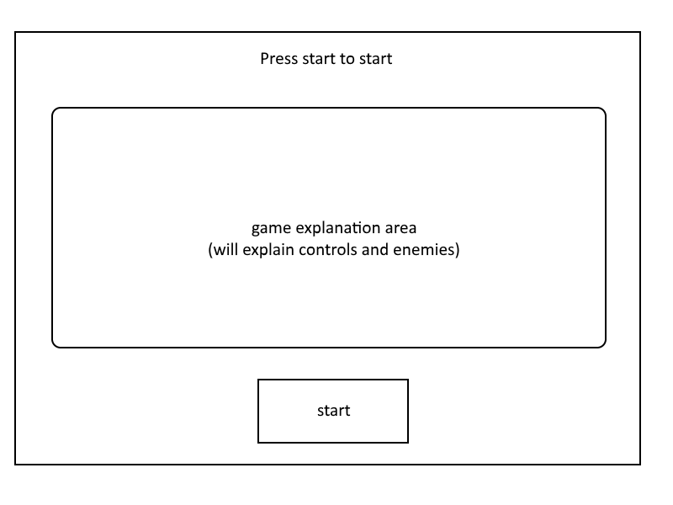

In-game:  
 GUI marked in red – shows life points, game points, and reload status  
 This sketch also shows the movement of most of the game objects

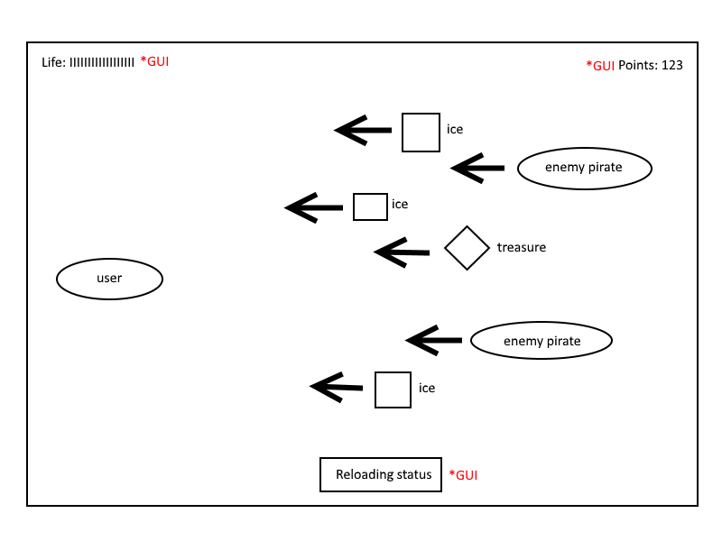

Game over screen:  
 Shows the amount of points achieved in that game and gives player option to restart game

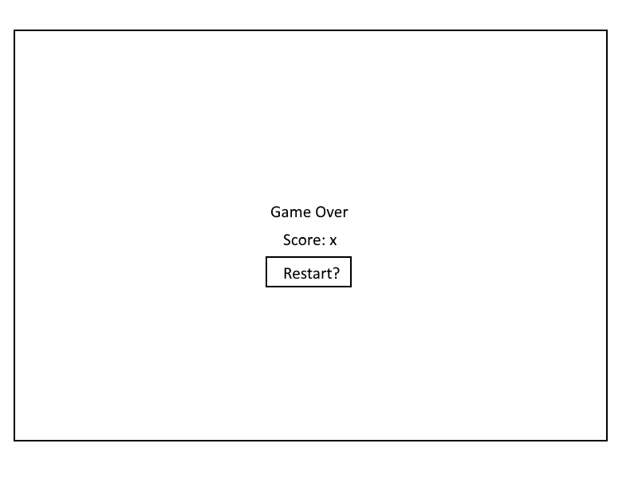

# Screen Descriptions

Start state:  
Some controls are displayed to the player

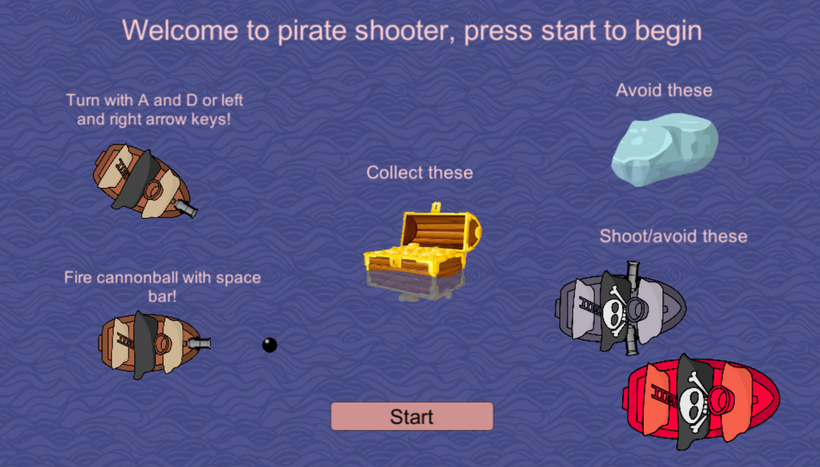

Game state – near game start:  
Score starts at 0 and the ship has 30 hull points (30 life points). Enemies and collectables appear on screen shortly after the game starts. Notification at the bottom shows the player is able to fire their cannonball.

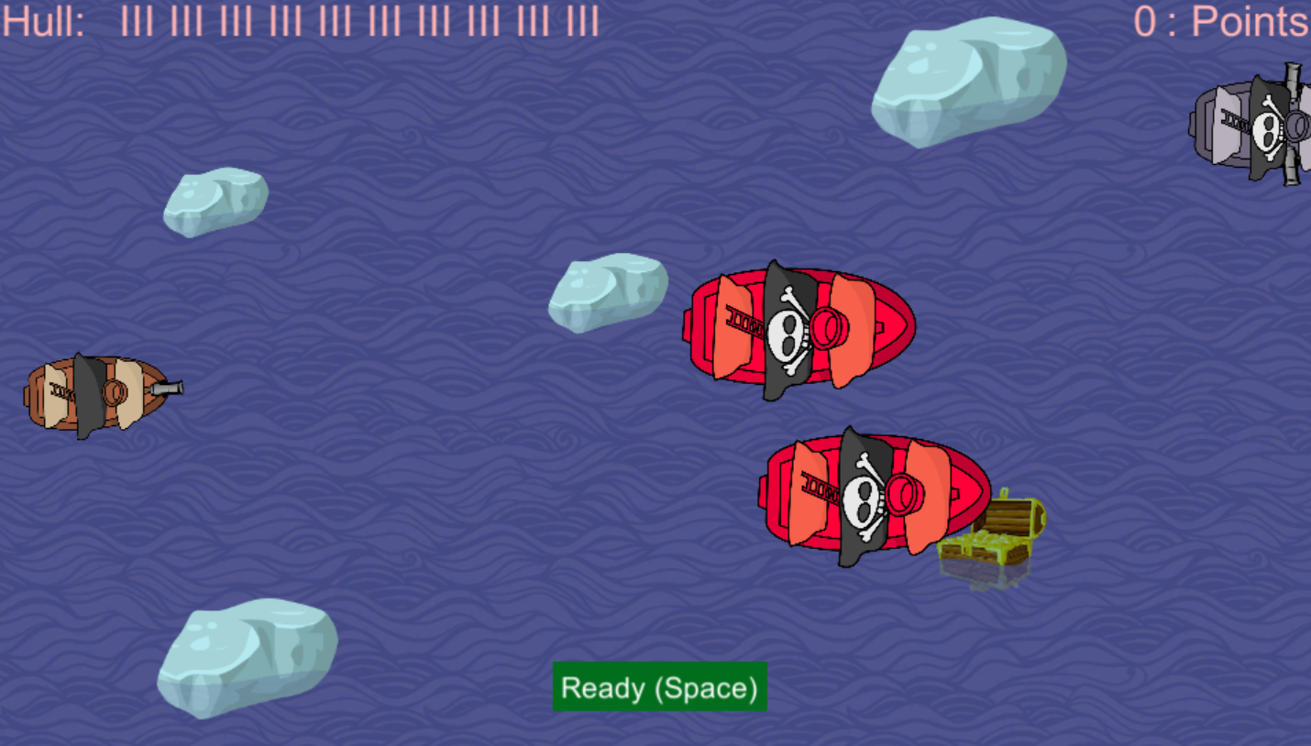

Game state – low health:  
Here the player is getting shot at by the grey pirate and has 4 hull points and 1100 points.

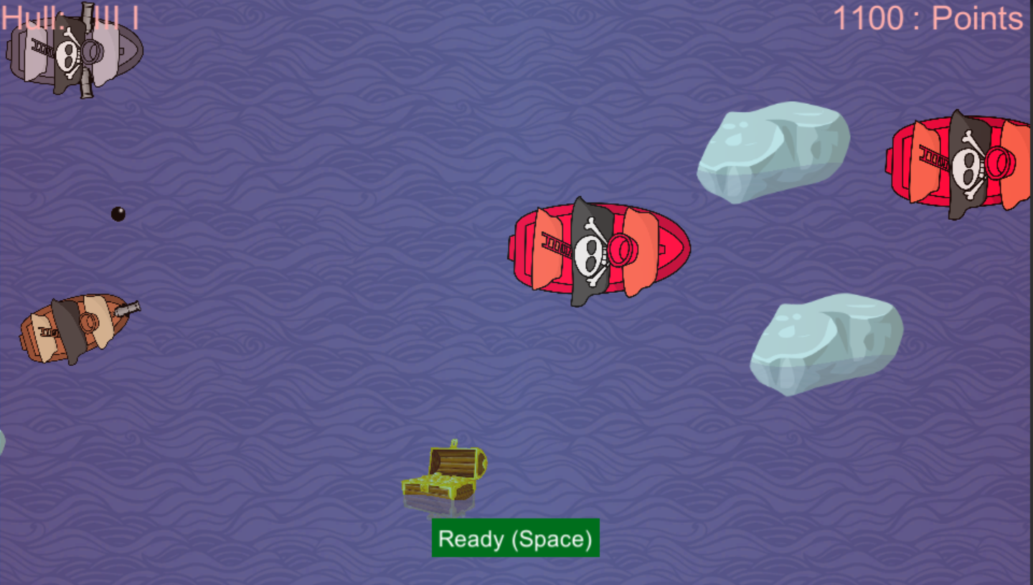

Game end state:  
Shows the score for that session and gives the player the ability to replay the level.

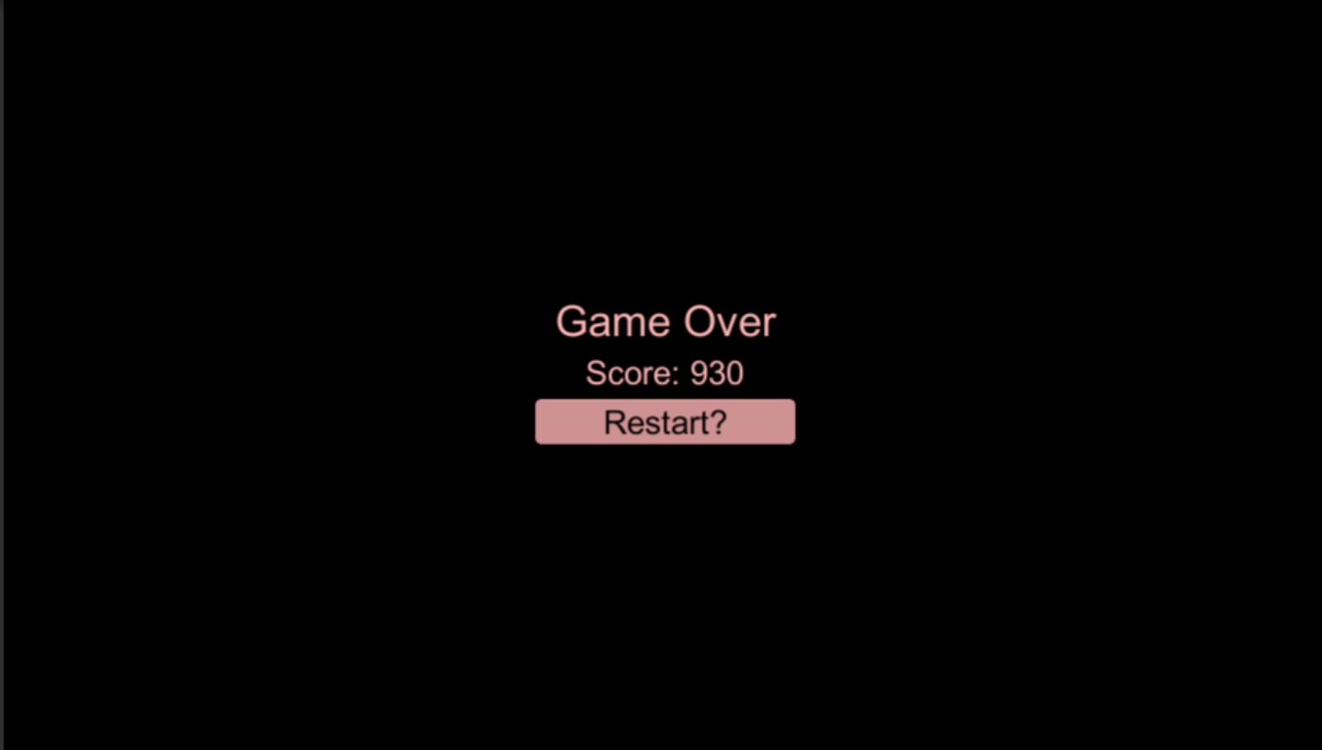

# Enemies

|  |  |
| --- | --- |
| Ice Block |  |
| C:\Users\Brendan\AppData\Local\Microsoft\Windows\INetCache\Content.Word\ice.png | Hull damage: 3  Description:  These ice blocks of different sizes are notorious for damaging small vessels such as the player’s ship |
| Red Pirate |  |
| C:\Users\Brendan\AppData\Local\Microsoft\Windows\INetCache\Content.Word\enemy_pirate.png | Hull damage: 10  Description:  These red pirate ships are slow moving, but are very punishing. A collision with one of these will take out a third of the players’ max hull points. A player can shoot these enemies to avoid them. |
| Grey Pirate |  |
| C:\Users\Brendan\AppData\Local\Microsoft\Windows\INetCache\Content.Word\enemy_pirate3.png | Hull damage: 5  Description:  These grey pirate ships are equipped with side facing cannons. Colliding with one of these will take out five of the players’ hull points. Once they move past the players’ ships, they will shoot three sets of cannonballs, two on each side. A player can shoot these enemies or avoid them, but beware, avoiding them can cause them to shoot at you. Sometimes it will be worthwhile to sacrifice your hull points to take one out before they have a chance to fire. |
| Grey Pirate Cannonballs |  |
| C:\Users\Brendan\AppData\Local\Microsoft\Windows\INetCache\Content.Word\cannonball.png | Hull damage: 3  Description:  These cannonballs are the objects that the grey pirates fire at the user if they are not destroyed in time. |

# Scoring

|  |  |
| --- | --- |
| Treasure |  |
| C:\Users\Brendan\AppData\Local\Microsoft\Windows\INetCache\Content.Word\chest.png | Points: 300  Description:  These treasure chests are littered throughout the game |
| Destroying Red Pirate |  |
| C:\Users\Brendan\AppData\Local\Microsoft\Windows\INetCache\Content.Word\enemy_pirate.png | Points: 50  Description:  Hitting this enemy with a cannonball will grant you points |
| Destroying Grey Pirate |  |
| C:\Users\Brendan\AppData\Local\Microsoft\Windows\INetCache\Content.Word\enemy_pirate3.png | Points: 30  Description:  Hitting this enemy with a cannonball will grant you points |

# Sound Index

|  |  |
| --- | --- |
| Points Earned Sound |  |
| Image result for music icon\ | File name: coin.wav  Description:  Played when a chest is touched or enemy ship is shot |
| Damage Taken Sound |  |
| Image result for music icon\ | File name: Explosion.wav  Description:  Played when the user takes damage (when hit by ice, enemy ship, or enemy cannon) |
| Background Music |  |
| Image result for music icon\ | File name: Mini-Boss - The Legend of Zelda- The Wind Waker.mp3  Description: Played on loop while in game |

# Art Index

|  |  |
| --- | --- |
| Cannonball |  |
| C:\Users\Brendan\AppData\Local\Microsoft\Windows\INetCache\Content.Word\cannonball.png | File name: cannonball.png  Description:  Used for cannonball objects |
| Treasure chest |  |
| C:\Users\Brendan\AppData\Local\Microsoft\Windows\INetCache\Content.Word\chest.png | File name: chest.png  Description:  Used for the chest pickups |
| Low health overlay |  |
| C:\Users\Brendan\AppData\Local\Microsoft\Windows\INetCache\Content.Word\damage.png | File name: damage.png  Description: Makes screen red while player has low health |
| Red Pirate |  |
| C:\Users\Brendan\AppData\Local\Microsoft\Windows\INetCache\Content.Word\enemy_pirate.png | File name: enemy\_pirate.png  Description:  One of the enemies |
| Grey Pirate |  |
| C:\Users\Brendan\AppData\Local\Microsoft\Windows\INetCache\Content.Word\enemy_pirate3.png | File name: enemy\_pirate3.png  Description:  One of the enemies |

|  |  |
| --- | --- |
| Explosion |  |
|  |  |
|  | File name: Explosion.png  Description:  Image atlas used for the explosion animation when enemies are destroyed or cannonball hits user |
| Ice |  |
| C:\Users\Brendan\AppData\Local\Microsoft\Windows\INetCache\Content.Word\ice.png | File name: ice.png  Description:  One of the obstacles |
| Ocean background |  |
| C:\Users\Brendan\AppData\Local\Microsoft\Windows\INetCache\Content.Word\ocean4.gif | File name: ocean4.gif  Description:  Used as the scrolling background |
| User ship |  |
| C:\Users\Brendan\AppData\Local\Microsoft\Windows\INetCache\Content.Word\pirate_doodle3.png | File name: pirate\_doodle3.png  Description: The sprite for the player’s avatar |